Lab 8.1.2.4 - Configuring Basic DHCPv4 on a Router

Topology
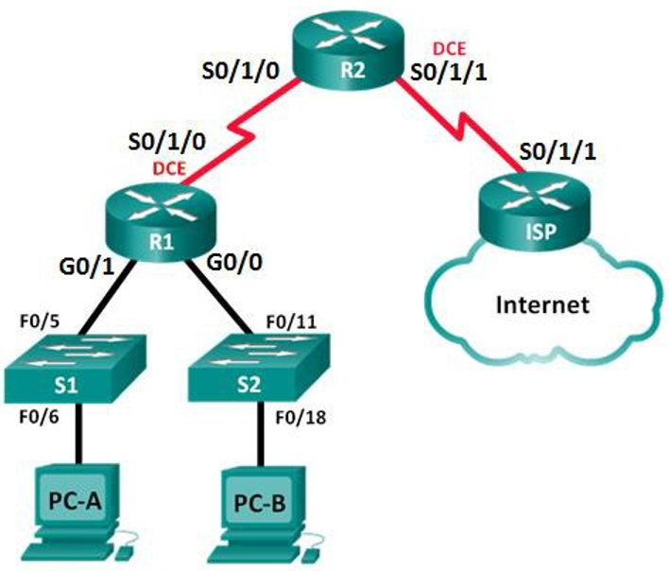

209.165.200.224 /27
192.168.2.252 /30

192.168.1.0 /24
192.168.0.0 /24

Addressing Table

Device | Interface | IP Address | Subnet Mask | Default Gateway
R1 | G0/0 | 192.168.0.1 | 255.255.255.0 | N/A
 | G0/1 | 192.168.1.1 | 255.255.255.0 | N/A
 | S0/1/0 (DCE) | 192.168.2.253 | 255.255.255.252 | N/A
R2 | S0/1/0 | 192.168.2.254 | 255.255.255.252 | N/A
 | S0/1/1 (DCE) | 209.165.200.226 | 255.255.255.224 | N/A
ISP | S0/1/1 | 209.165.200.225 | 255.255.255.224 | N/A
PC-A | NIC | DHCP | DHCP | DHCP
PC-B | NIC | DHCP | DHCP | DHCP

Objectives
Part 1: Build the Network and Configure Basic Device Settings
Part 2: Configure a DHCPv4 Server and a DHCP Relay Agent

Background / Scenario
The Dynamic Host Configuration Protocol (DHCP) is a network protocol that lets network administrators manage and automate the assignment of IP addresses. Without DHCP, the administrator must manually assign and configure IP addresses, preferred DNS servers, and default gateways. As the network grows in size, this becomes an administrative problem when devices are moved from one internal network to another.
In this scenario, the company has grown in size, and the network administrators can no longer assign IP addresses to devices manually. Your job is to configure the R2 router to assign IPv4 addresses on two different subnets connected to router R1.
- Build the Network and Configure Basic Device Settings
In Part 1, you will set up the network topology and configure the routers and switches with basic settings, such as passwords and IP addresses. You will also configure the IP settings for the PCs in the topology.
  - Configure basic settings for each router.
    - Console into the router and enter global configuration mode.
    - Copy the following basic configuration and paste it to the running-configuration on the router.
no ip domain-lookup
service password-encryption
enable secret class
banner motd #
Unauthorized access is strictly prohibited. #
line con 0
password cisco
login
logging synchronous
line vty 0 4
password cisco
login
    - Configure the host name as shown in the topology.
    - Configure the IPv4 addresses on the router as shown in the topology.
    - Set the DCE serial interfaces with a clock rate of 128000.
  - Configure dynamic, default, and static routing on the routers.
    - Configure RIPv2 for R1.
R1(config)# router rip
R1(config-router)# version 2
R1(config-router)# network 192.168.0.0
R1(config-router)# network 192.168.1.0
R1(config-router)# network 192.168.2.252 se pone automáticamente 192.168.2.0
R1(config-router)# no auto-summary
    - Configure RIPv2 and a default route to the ISP on R2.
R2(config)# router rip
R1(config-router)# version 2
R2(config-router)# network 192.168.2.252 se pone automáticamente 192.168.2.0
R2(config-router)# default-information originate
R1(config-router)# no auto-summary
R2(config-router)# exit
R2(config)# ip route 0.0.0.0 0.0.0.0 209.165.200.225

    - Configure a static route on ISP to reach the networks on the R1 and R2 routers.
ISP(config)# ip route 192.168.0.0 255.255.252.0 209.165.200.226

192.168.1.0 .00000001
192.168.0.0 .00000000
192.168.2.252 .00000010

  - Verify network connectivity between the routers.
If any pings between routers fail, correct the errors before proceeding to the next step. Use show ip route and show ip interface brief to locate possible issues.
  - Verify the host PCs are configured for DHCP.
- Configure a DHCPv4 Server and a DHCP Relay Agent (AGENTE DE RETRANSMISIÓN DHCP)
To automatically assign address information on the network, you will configure R2 as a DHCPv4 server and R1 as a DHCP relay agent.
  - Configure DHCPv4 server settings on router R2.
On R2, you will configure a DHCP address pool for each of the R1 LANs. Use the pool name R1G0 for the G0/0 LAN and R1G1 for the G0/1 LAN. You will also configure the addresses to be excluded from the address pools. Best practice dictates that excluded addresses be configured first, to guarantee that they are not accidentally leased to other devices.
Exclude the first 9 addresses in each R1 LAN starting with .1. All other addresses should be available in the DHCP address pool. Make sure that each DHCP address pool includes a default gateway and a DNS server (209.165.200.225).
On the lines below, write the commands necessary for configuring DHCP services on router R2, including the DHCP-excluded addresses and the DHCP address pools.
R2(config)# ip dhcp excluded-address 192.168.0.1 192.168.0.9
R2(config)# ip dhcp excluded-address 192.168.1.1 192.168.1.9

R2(config)# ip dhcp pool R1G1
R2(dhcp-config)# network 192.168.1.0 255.255.255.0
R2(dhcp-config)# default-router 192.168.1.1
R2(dhcp-config)# dns-server 209.165.200.225
R2(dhcp-config)# exit

R2(config)# ip dhcp pool R1G0
R2(dhcp-config)# network 192.168.0.0 255.255.255.0
R2(dhcp-config)# default-router 192.168.0.1
R2(dhcp-config)# dns-server 209.165.200.225
On PC-A or PC-B, open a command prompt and enter the ipconfig /all command. Did either of the host PCs receive an IP address from the DHCP server? Why?
____________________________________________________________________________________
The host computers will not have received IP addresses from the DHCP server at R2 until R1 is configured as a DHCP relay agent.
Los equipos host no habrán recibido direcciones IP del servidor DHCP en R2 hasta que R1 esté configurado como agente de retransmisión DHCP.
A DHCP relay agent is any host that forwards DHCP packets between clients and servers.

  - Configure R1 as a DHCP relay agent.
Configure IP helper addresses on R1 to forward all DHCP requests to the R2 DHCP server.
On the lines below, write the commands necessary to configure R1 as a DHCP relay agent for the R1 LANs.
R1(config)# interface g0/0
R1(config-if)# ip helper-address 192.168.2.254
R1(config-if)# exit
R1(config)# interface g0/1
R1(config-if)# ip helper-address 192.168.2.254
  - Record IP settings for PC-A and PC-B.
On PC-A and PC-B, issue the ipconfig /all command to verify that the PCs have received IP address information from the DHCP server on R2. Record the IP and MAC address for each PC.
_______________________________________________________________________________________
_______________________________________________________________________________________

Based on the DHCP pool that was configured on R2, what are the first available IP addresses that PC-A and PC-B can lease?
_______________________________________________________________________________________
PC-B: 192.168.0.10, and PC-A: 192.168.1.10
  - Verify DHCP services and address leases on R2.
    - On R2, enter the show ip dhcp binding command to view DHCP address leases.
Along with the IP addresses that were leased, what other piece of useful client identification information is in the output?
__________________________________________________________________________________
The client hardware addresses identify the specific computers that have joined the network.
Las MAC address de las computadoras que se han unido a la red.
    - On R2, enter the show ip dhcp pool command to view the DHCP pool settings.
In the output of the show ip dhcp pool command, what does the current index refer to?
____________________________________________________________________________________
La siguiente dirección disponible para arrendamiento.
The next available address for leasing.
    - On R2, enter the show run | begin dhcp command to view the DHCP configuration in the running configuration.
    - On R1, enter the show run | begin interface GigabitEthernet0/0 command and show run | begin interface GigabitEthernet0/0 to view the DHCP relay configuration in the running configuration file.
Reflection
What do you think is the benefit of using DHCP relay agents instead of multiple routers acting as DHCP servers?
_______________________________________________________________________________________
_______________________________________________________________________________________
_______________________________________________________________________________________
_______________________________________________________________________________________
Having a separate router DHCP server for each subnet would add more complexity and decrease centralized management for the network. It would also require that each router work harder to manage its own DHCP addressing, in addition to the primary function of routing traffic. One DHCP server (router or computer) that is dedicated to the job is easier to manage and more centralized.

Tener un servidor DHCP de enrutador separado para cada subred agregaría más complejidad y disminuiría la administración centralizada de la red. También requeriría que cada enrutador trabaje más para administrar su propio direccionamiento DHCP, además de la función principal de enrutar el tráfico. Un servidor DHCP (enrutador o computadora) dedicado al trabajo es más fácil de administrar y más centralizado.

